**Project Name:** Order Management System

**Github Link:** https://github.com/projectsforstudents2022/Order_Management_System.git

**Why was this project created?**

Inventory management system refers to the procedures and systems used by a company to manage its stock using technology. This system can be used to store inventory information, maintain stock levels, update inventory depending on sales information, and provide sales and inventory reports on a daily or weekly basis. The use of an inventory management system is another crucial tool for tracking huge shipments automatically. A computerized inventory management system reduces human inaccuracy in stock recording.

**What problem is it solving?**

The goal of this project is to classify each component of the sales and inventory management system. With the help of this system, we are resolving several issues that have an impact on direct sales management and buy management. Businesses that handle transactions involving consumer goods need to use inventory management systems to assure quality control. A large retail store may run out of supply on a crucial item without appropriate inventory control. When it is time to record, a competent inventory management system will notify the wholesaler.

**Entire explanation of project**

* **PROPOSED APPROACH**

The project Inventory Management System is a fully functional desktop application built with Visual Studio Software and.Net technology. The primary goal of the project is to create an inventory management system model that would present all of the organization's stock information. It is a desktop programme that runs on the intranet and contains an admin component for managing inventory and keeping the inventory system up to date.

This desktop programme is based on an organization's stock management. The application includes information on the organization's general profile, sales information, purchase information, and the stock that is still available. Along with the specifics of the transaction balance, this application also provides the stock's remaining balance.

Each new stock is formed, entitled, and given a name and entry date. It can also be updated as necessary based on transactions or sales returns, as applicable. The login page is built in this case to safeguard the organization's stock management and shield it from theft and improper usage of the inventory.

* **RESULT**

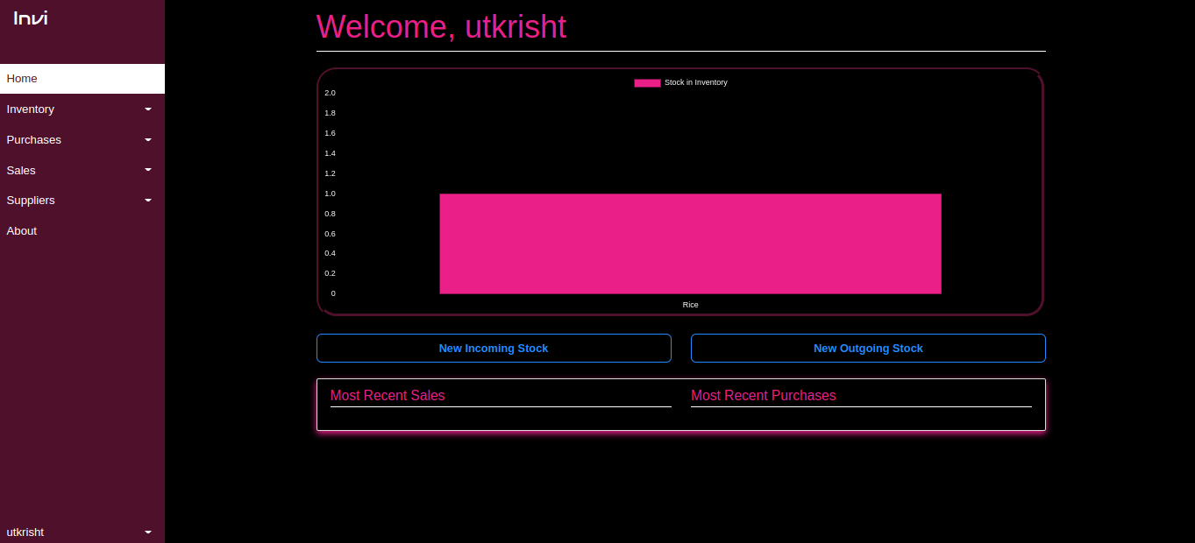

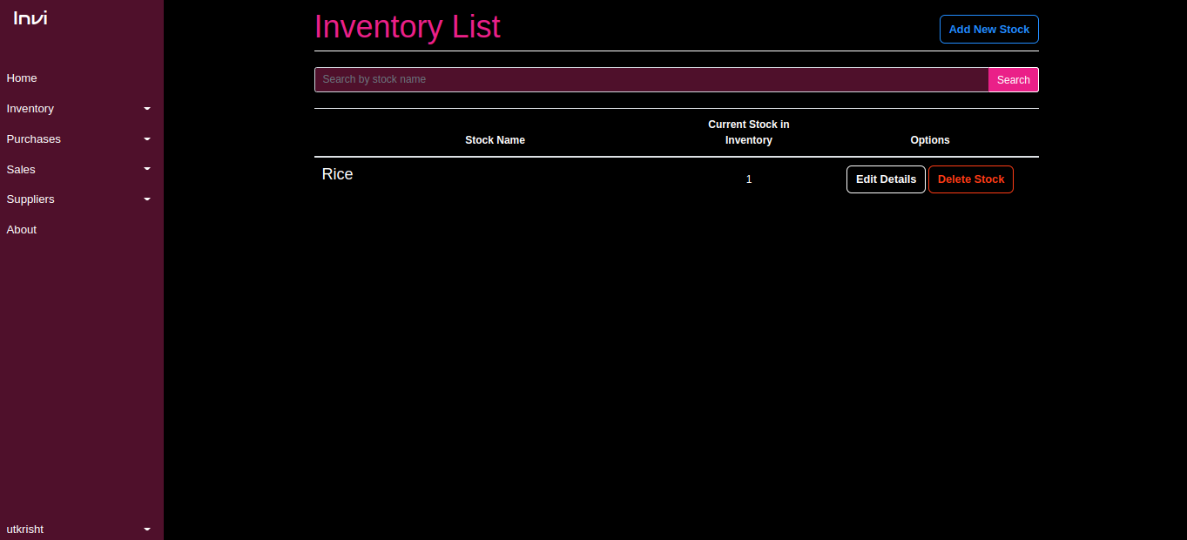

**CONCLUSION**

A basic desktop-based programme for small businesses is the inventory management system. It contains all essential elements required for a small business. Our team has been successful in creating an application that allows us to update, insert, and delete items as needed. This tool also offers a straightforward report each day that includes the daily sales and purchases. This application is appropriate for small organizations with few female employees.